

FPT-aptech computer education

Oline help deck

fat1_T1107I_Group 5
Group Member | Nguyễn Lê Bảo Sơn(GL) -0879  Nguyễn Việt An - 1696  Đào Thị Dung- 0806
Instructor | Nguyễn Tuân

- Hanoi, 3/2013 -

1.Index:

1.Index: 1

2. Problem Definition 2
2.1. Problem Abstraction 3
2.2. The Current System 3
2.3. The Proposed System 3
Non-Financial: 4
Financials: 4
2.4. Boundaries of the System 5
2.5. Development Environment 5

3. Requirements and Business Flow 5
3.1. Customer Requirement Specification 5
3.2. Activity Diagram 6
3.3. Use Case Diagram 12
3.4. Use Case Specification 13
3.8.Accept Event Register 19
3.5. Other Diagrams <Optional> 19

4. Design 20
4.1. System Architecture 20
4.2. Class Diagram 20
4.3. Class Diagram Explanation 22
4.4. Sequence Diagram : 22
4.5. Entity Relationship Diagram 28
4.6. Database Design 28
4.7. Algorithms (optional) 32

5. System Prototype 33

6. Management and Project Planning 34
6.1. Management Approach 34
6.2. Project Plan 34
6.3. Task Sheet 35

7. Checklists 36
7.1. Check List of Validation 36
7.2. Submission Checklist 36

8. Screenshots 37

Problem Definition

Financials:
This project is aimed at developing an Online Help Desk (OHD) for the facilities in the campus. This is an Intranet based application that can be accessed throughout the campus. This system can be used to automate the workflow of service requests for the various facilities in the campus. This is one integrated system that covers different kinds of facilities like class-rooms, labs, hostels, mess, canteen, gymnasium, computer centre, faculty club etc. Registered users (students, faculty, lab-assistants and others) will be able to log in a request for service for any of the supported facilities. These requests will be sent to the concerned people, who are also valid users of the system, to get them resolved. There are features like email notifications/reminders, addition of a new facility to the system, report generators etc in this system.

Development Environment
Hardware
- Pentium IV CPU 1.80 GHz.
- Hard disk requirement: minimum 8 GB.
- 512 Megabytes of Ram or higher.
Software
- Apache Tomcat 6.0.26.
- Internet Explorer 8, Firefox 3.6.
- Microsoft SQL Server 2005.
- NetBeans IDE 6.9, JDK 1.6. h
- Adobe Firework CS 5, SmartDraw VP.
- Microsoft Word 2010.
- Tortoise SVN.
- Window 2000, XP or higher.

Requirements and Business Flow

Customer Requirement Specification
Our client wants the application to perform the following tasks :

- Customers can:
- Visit website
- Register or login to website.
- View product , rate product ,add to shoppingcart.
- checkout .
- update profile.
- view history order.
- Admin can manage:
- Details of Customers
- Details of the Warehouses
- Detail of product
- Rejection product
- Accepting order booking from user.

Activity Diagram
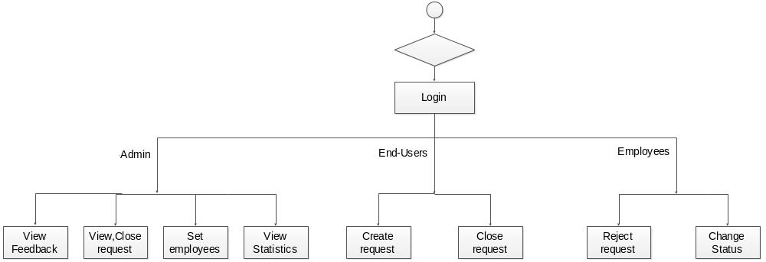

- Activity diagram “ Register”

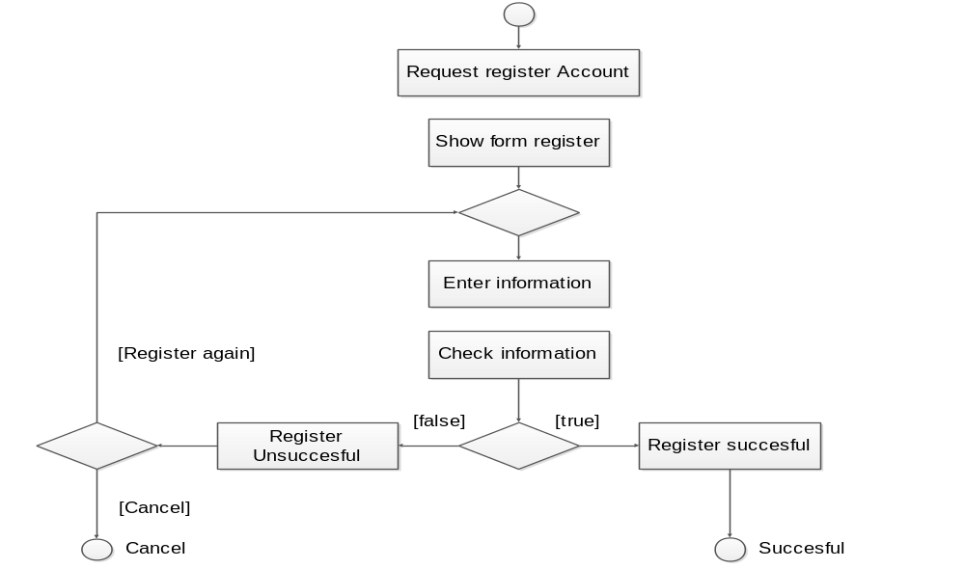

- Activity diagram “Login”
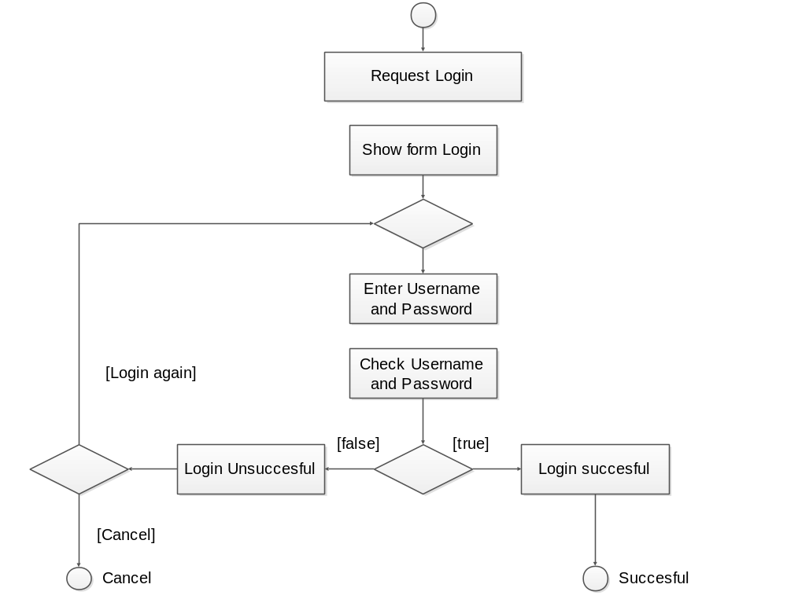

- Activity diagram “ Send feedback ”
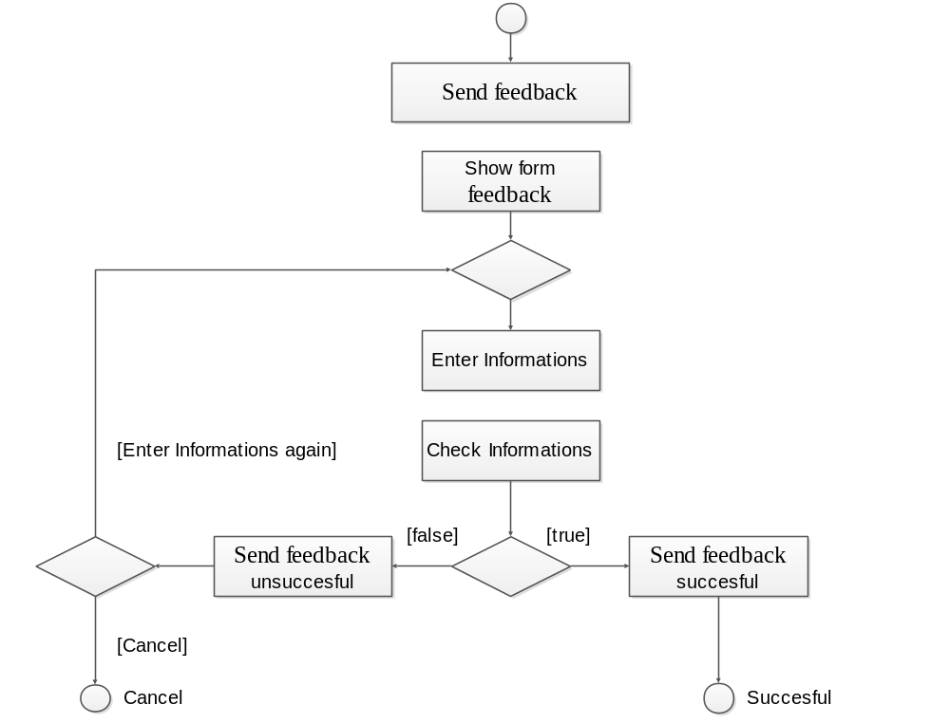

- Activity diagram “Change Password ”
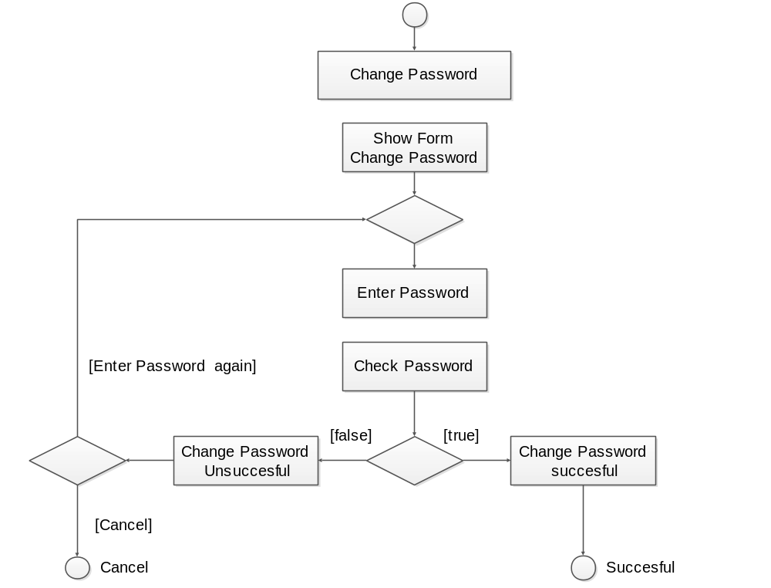

- Activity diagram “View requests ”
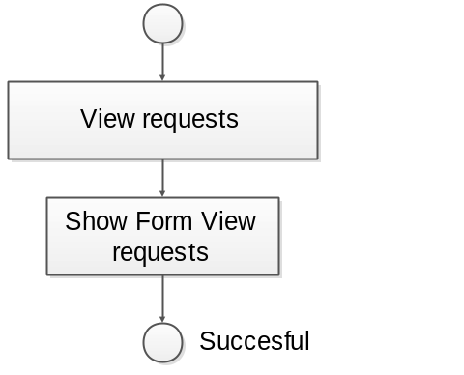

- Activity diagram “Create new requests”
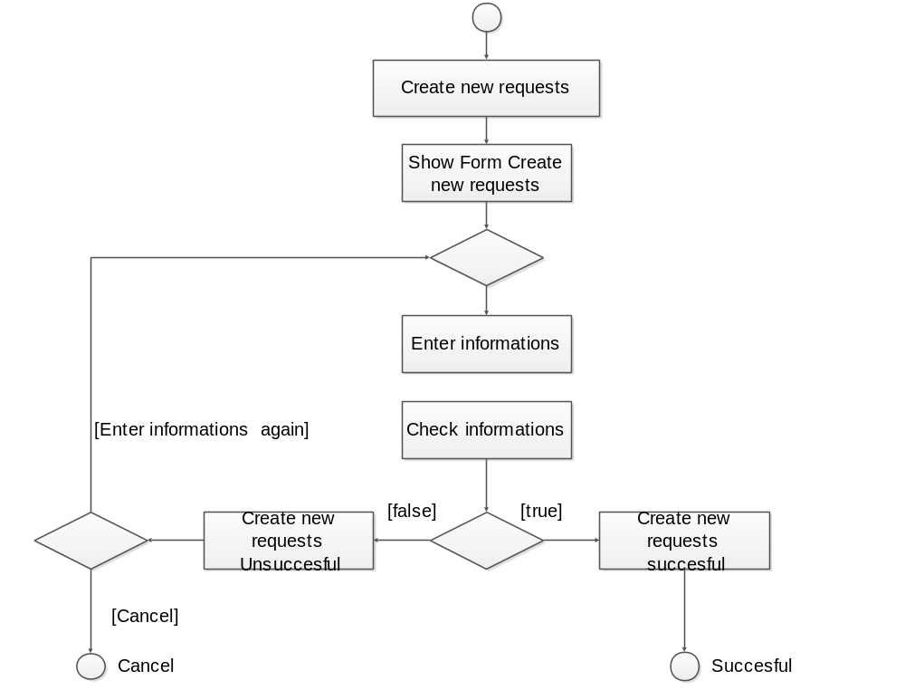

- Activity diagram “ Update status of request “
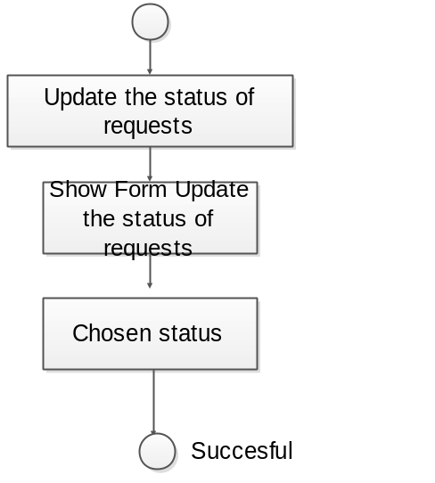

- Activity diagram “ Register users of the system“
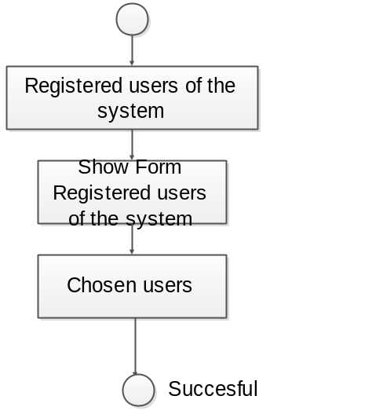

- Activity diagram “View message “

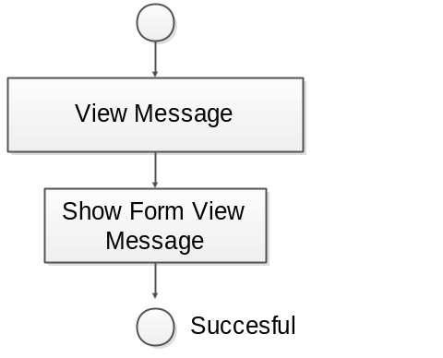

- Activity diagram “ View Statistics“
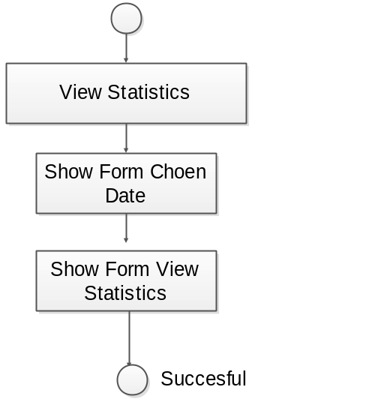

Use Case Diagram
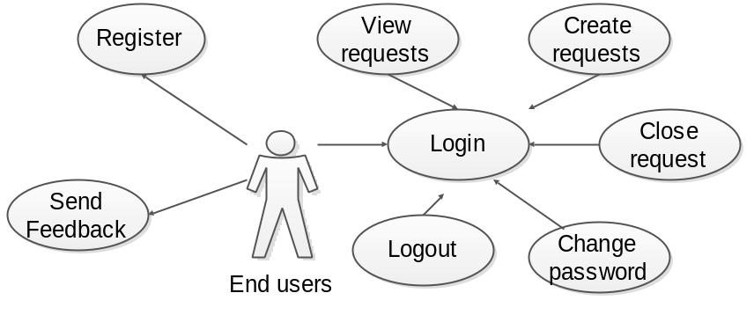
End users UseCase
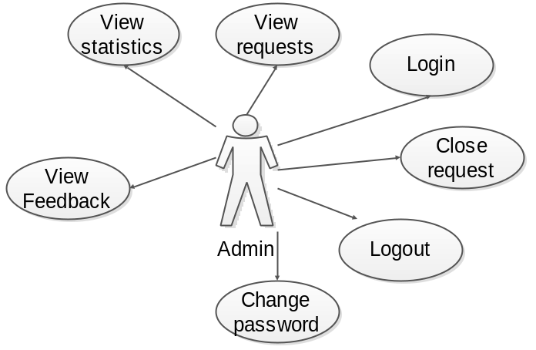
Admin UseCase

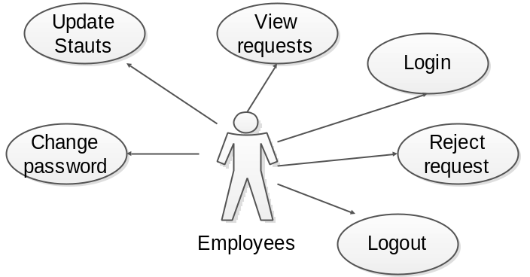

Employees UseCase

Use Case Specification

Use Case Name | Register
Actors | Employees, end -users
Brief Description | - Use case allows Employees and end -users register to system
Preconditions | - The person has not already been registered with System
Basic Flow of Events | 1. The use case begins when customer click on “register “ button in website.  2.The system show register form contains  Fields:  - User name.  - Password.  - Type  - FullName.  - Age  - Address  3. Employees, end –users enter information into form.  4.The system checks the validity of the information.  5. Save information of customer to database  6.System display successful register message.
Alternative Flows | A1.Exist use name:  If in step 4 of the basic flow employees , end-users enter a usename existed in the database then:  - System display error message.  - The use case resumes at step 3 of Basic Flow enter other username.  A2.Age is invalid:  If in step 4 of the basic flow customer enter age is invalid in the database then:  - System display error message.  - The use case resumes at step 3 of Basic Flow re-enter age  A3.(Username, password, ,fullName, Address, age) is null:  If in step 4 of the basic flow customer not enter (Full name, password, Address, BirthDay) then:  - System display error message.  - The use case resumes at step 3 of Basic Flow enter requiment information.
Exit Options | - Customer click on “Cancel” button
Special Requirements
Post Condition | - Customer have a new account in system.

Use Case Name | Login
Actors | All users
Brief Description | -Actors use this use case to login to system
Preconditions
Basic Flow of Events | 1. Actors click on “Login “ button in website.  2.The system show” login” form contains  Fields :  - User name.  - Password.  3. Actors enter username and password into form.  4.The system checks the validity of username and password .  5.System logs the Actors into the system.
Alternative Flows | If in the step 4 Basic Flow,Users enter invaild user name and/or password then:  1.System display error message.  2.The use case resumes at step 3 of Basic Flow.
Exit Options | - Actors click on “Cancel” button
Special Requirements
Post Condition | - Actors login to system

Use Case Name | Change password
Actors | All users
Brief Description | - Actors use this use case to chage password login to system
Preconditions | The Actors must be logged into system before this use case begins.
Basic Flow of Events | 1. The use case begins when Actors click on “Change password” menu on the website.  3.The system display ” change password” form contains Fields:  - Old password.  - New password.  - Confirm new password.  4. Actors enter infomation in form.  5. Actors click on “Submit” button.  6.The system checks the validity of the information.  7.System save information to data base.  8. System display successful message.
Alternative Flows | A1.Old password invalid.  If in the step 6 Basic users enter invaild old password :  1.System display error message.  2.The use case resumes at step 4 of Basic Flow re-enter old password.  A2. Confirm invalid.  If in the step 6 Basic Flow, users enter new password and confirm new password is not the same:  1.System display error message.  2.The use case resumes at step 4 of Basic Flow re-confirm new password.
Exit Options | - Customer click on “Cancel” button
Special Requirements
Post Condition | - password of customer is changed to data base.

Use Case Name | View requests
Actors | All users
Brief Description | -The actor must be logged into system before this use case begins.  - Use case allows the customer view requests
Preconditions | -The requests must be logged into system before this use case begins.
Basic Flow of Events | 1. The use case begins when customer click on “View requests “ menu in website.  2.System load products in database .  3.System display result to user.
Alternative Flows
Exit Options
Special Requirements
Post Condition | - requests of users is displayed.

Use Case Name | View feedback
Actors | Admin
Brief Description | - Use case allows the Admin view all feedback
Preconditions | -The actor must be logged into system before this use case begins.
Basic Flow of Events | 1. The use case begins when Admin click on “View feedback “menu in the website..  2.System display feedback.
Alternative Flows
Exit Options
Special Requirements
Post Condition | - All feedback are displayed.

Use Case Name | View messages
Actors | All- users
Brief Description | - Use case allows the user view all message
Preconditions
Basic Flow of Events | 1. The use case begins when user click on message icon in the website..  2.System display messages.
Alternative Flows
Exit Options
Special Requirements
Post Condition | - All messages are displayed.

Use Case Name | Close request
Actors | End-users , admin
Brief Description | -The actor must be logged into system before this use case begins.  - Use case allows the End-users , admin close request
Preconditions
Basic Flow of Events | 1. The use case begins when End-users click on “close “ in the table requests  2. System save information to database
Alternative Flows
Exit Options
Special Requirements
Post Condition | - a request are close.

Use Case Name | Send feedback
Actors | End-users
Brief Description | - Use case allows the End-users send a feedback.
Preconditions
Basic Flow of Events | - This use case begin when End-users click on “send feedback” menu.  - System display a form contain :  - Name.  - email.  - content.  End-users enter information into form.  - End-users click on “Send” button.  - System save information to database.
Alternative Flows
Exit Options | End-users click on “Cancel” button
Special Requirements
Post Condition | -A feedBack of End-users is sent.

Use Case Name | Create new requests
Actors | End-users
Brief Description | - Use case allows create new requests
Preconditions | -The actor must be logged into system before this use case begins.  -When End-user click on “Create new requests”
Basic Flow of Events | 1.The system display Create new requests form contain :.  - type  - remark  2.Dealer manager enter information into form  3. The system checks this product into database  4. End-user click on “send” button.  5. System display successful massage
Alternative Flows | .A: remark is null  - System display error message.  - The use case resumes at step 2 of Basic Flow enter remak
Exit Options | - End-user click on “Cancel” button
Special Requirements
Post Condition | - End-user have a rejection product list

Use Case Name | Update status of request
Actors | Employees
Brief Description | - Use case allows the admin update status of request.
Preconditions
Basic Flow of Events | 1. in the table requests , Employees chose status.  2. The use case begins when Employees click on “change “ in the table requests  3. System save information to database
Alternative Flows
Exit Options
Special Requirements
Post Condition | -Status of request has been update

Use Case Name | assign request to registered employees
Actors | Admin
Brief Description | - Use case allows the admin assign request to registered employees.
Preconditions | -The actor must be logged into system before this use case begins.
Basic Flow of Events | 1. in the table requests , Admin chose employees name.  2. The use case begins when Admin click on “set “ in the table requests  3. System save information to database
Alternative Flows
Exit Options
Special Requirements
Post Condition | request has been assigned

3.8.Accept Event Register

Other Diagrams <Optional>

Design

System Architecture
Website bases on MVC (Model-View-Controller) architecture

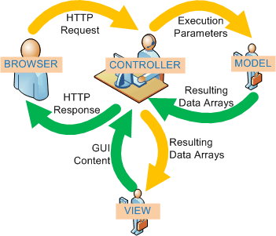
Web-Based Distributed MVC Architecture of the Project

Class Diagram

- Class diagram “Manage request”
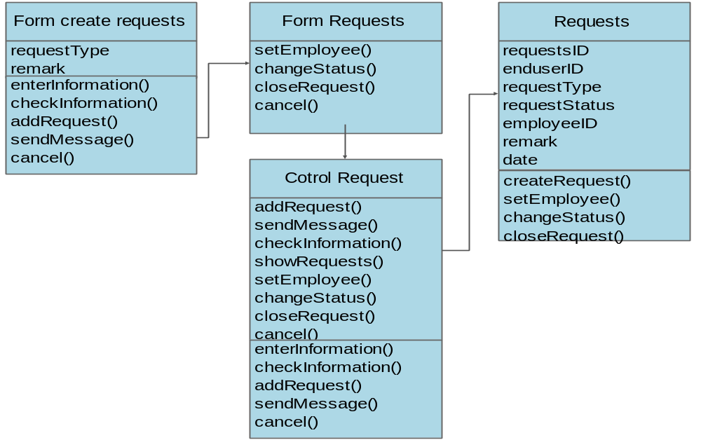

- Class diagram “Manage Feedback “
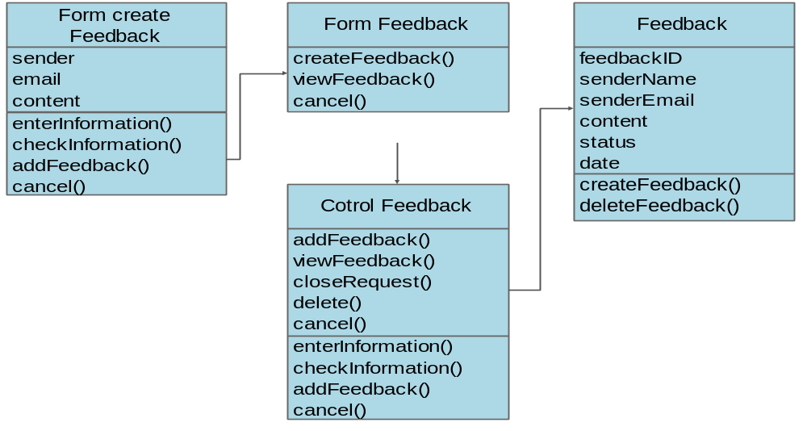

- Class diagram “Manage message “
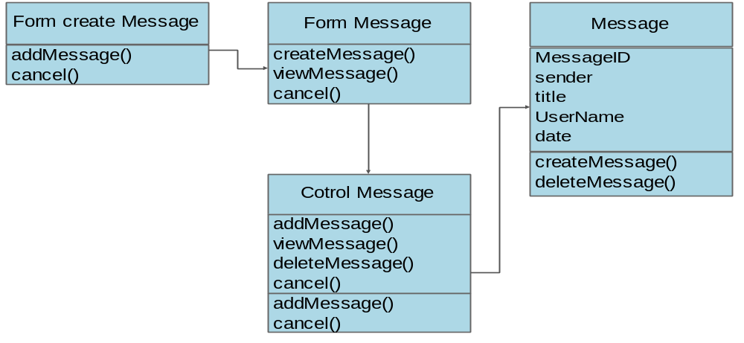

- Class diagram “Manage users”
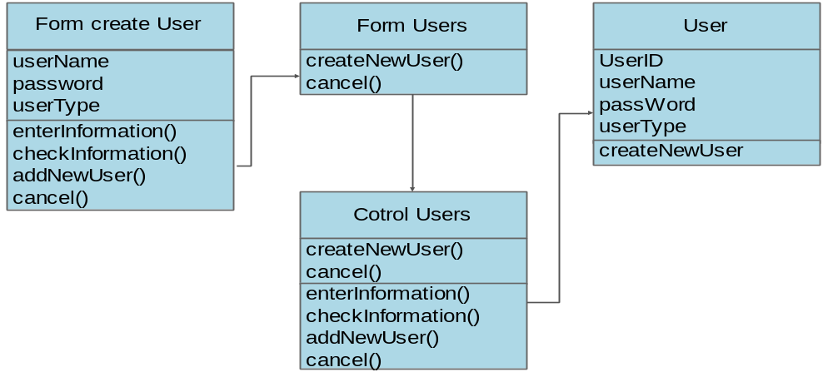

Class Diagram Explanation

<Provide brief explanation about the class diagram above. You do not need to explain “obvious” parts of your class diagram. For example, I know what a “Login” class is. Don’t say “The login class was created to store login information.”>

Sequence Diagram :
- Sequence diagram “ Register ”

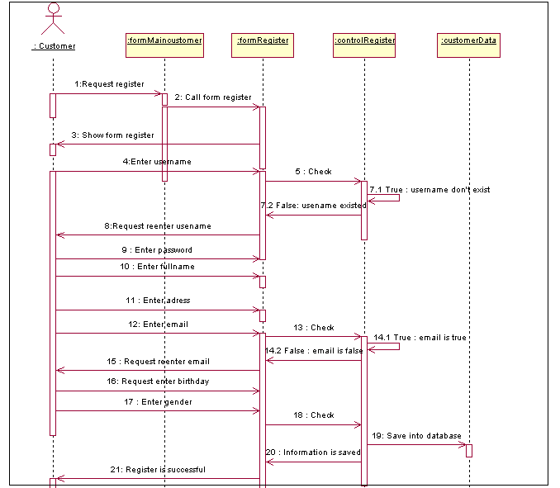

- Sequence diagram “Login”
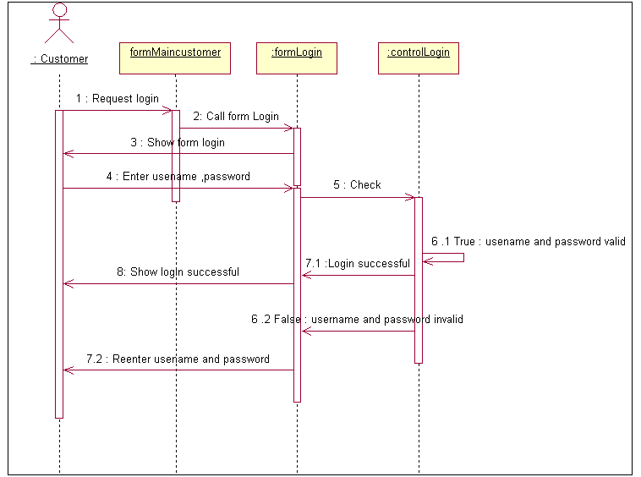

- Sequence diagram “Change password “

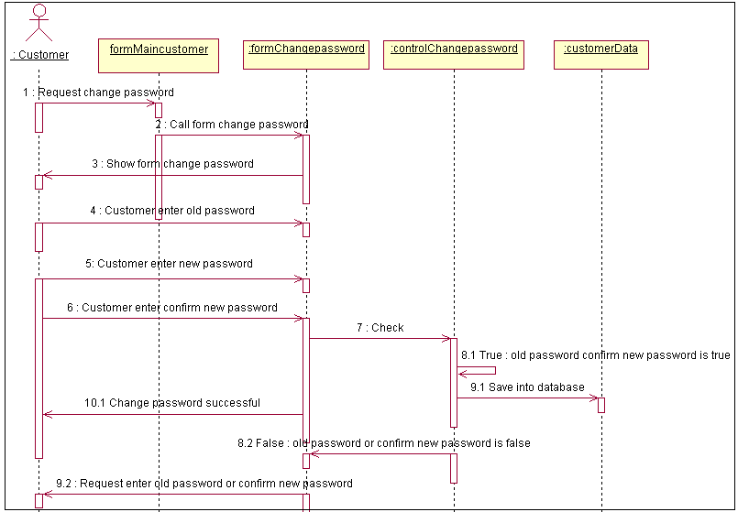

- Sequence diagram “Send feedback “

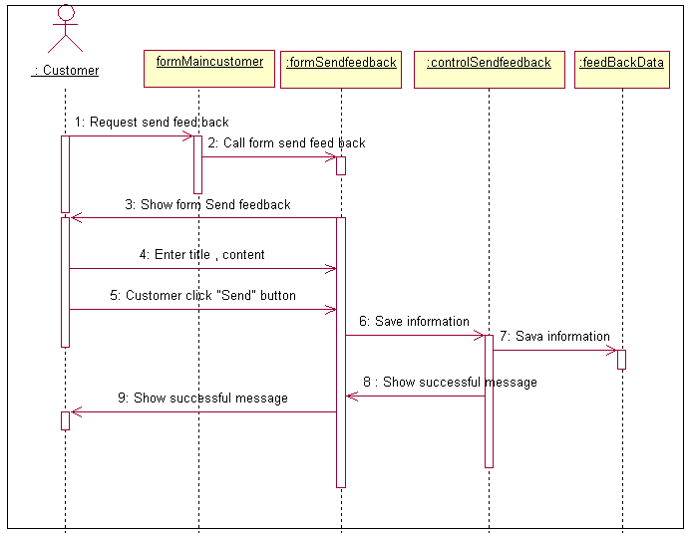

- Sequence diagram ”Manage customers “
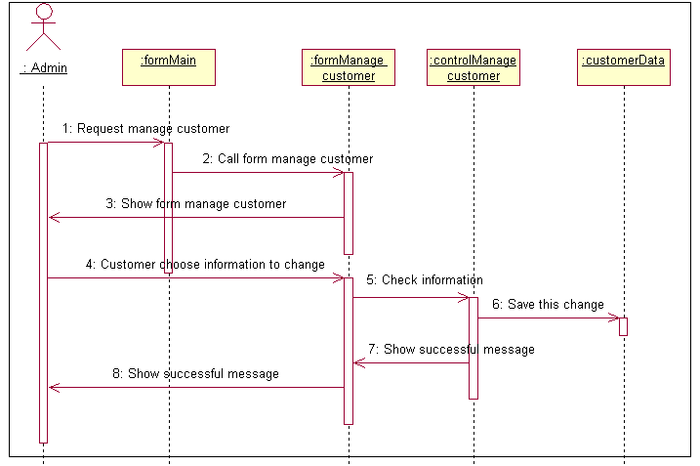
- Sequence diagram “ View feedback”
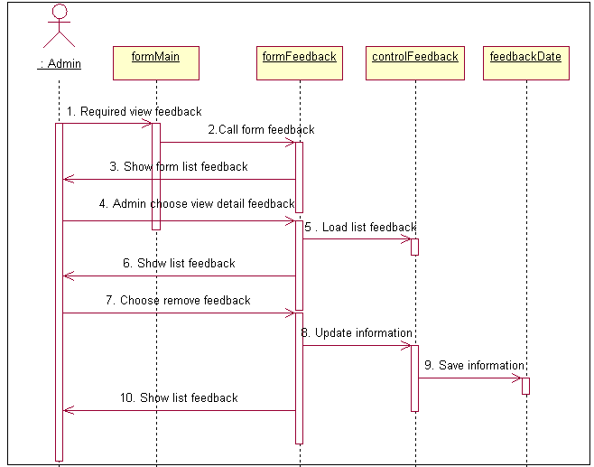

Entity Relationship Diagram
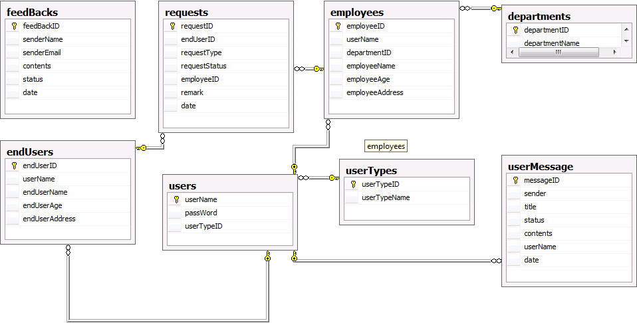

Database Design

Table : userTypes
Field Name | Data Type | Null | Key | Description
usertypeID | Int | No | PK | ID of user type
usertypeName | varchar(20) | No |  | Name of user type

Table : users
Field Name | Data Type | Null | Key | Description
userName | Varchar(15) | No | PK | UserName of customer
passWord | Varchar(15) | No |  | Password of customer
userTypeID | Int | No | FK | References userTypes

Table : endUsers
Field Name | Data Type | Null | Key | Description
endUserID | Int | No | PK | ID of end User
userName | varchar(15) | No | FK | references users
enduserName | varchar(50) | No |  | Name of end User
endUserAge | Int | No |  | Age of end User
endUserAddress | varchar(50) | No |  | Address of end User

Table : departments
Field Name | Data Type | Null | Key | Description
departmentID | Int | No | PK | ID of department
departmentName | varchar(20) | No |  | Name of department

Table : employees
Field Name | Data Type | Null | Key | Description
employeeID | Int | No | PK | ID of employee
userName | varchar(15) | No | FK | references users
departmentID | Int | No | FK | references departments
employeeName | varchar(20) | No |  | Name of employee
employeeAge | int | No |  | Age of employee

Table : requests
Field Name | Data Type | Null | Key | Description
requestID | Int | No | PK | ID of request
endUserID | int | No | FK | references endUsers
requestType | varchar(20) | No |  | Type of request
requestStatus | varchar(20) | No |  | Status of request
employeeID | Int | No | FK | references employees
remark | varchar(100) | No |  | remark of request
date | smalldatetime | No |  | date of request

Table : userMessage
Field Name | Data Type | Null | Key | Description
messageID | Int | No | PK | ID of the message
sender | varchar(50) | No |  | Name of sender
title | datetime | No |  | title of the message
status | Int | No |  | status of the message
Contents | Int | No |  | Contents of the message
userName | varchar(15) | No | FK | recipient
date | smalldatetime |  |  | date of the message

Table : feedBacks
Field Name | Data Type | Null | Key | Description
feedBackID | Int | No | PK | ID of the feedBack
senderName | varchar(50) | No |  | Name of the sender
senderEmail | varchar(100) | No |  | Email of the sender
contents | varchar(1000) | No |  | contents of the feedBack
status | varchar(20) | No |  | status of the feedBack
date | smalldatetime | No |  | date of the feedBack

Algorithms (optional)

System Prototype

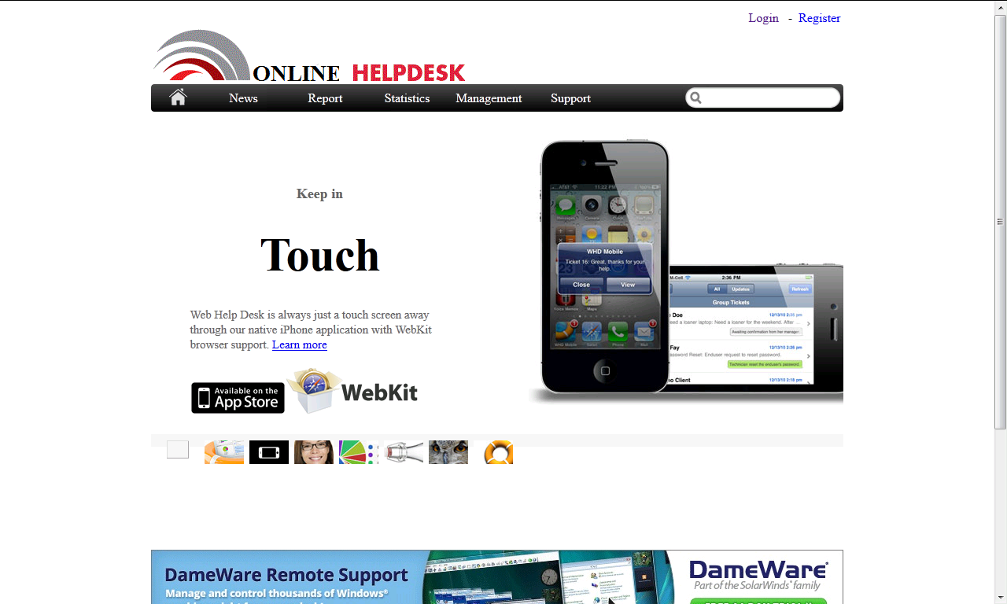

Management and Project Planning

Management Approach

Group leader will make a list of tasks, and assign tasks for each member of group. If member has any issues about assigned tasks, group will have a meeting to discuss and assign tasks again. After members submit assigned tasks to SVN server, group leader will check each task and give any issues or bugs which member must fix or discuss again with group

Project Plan

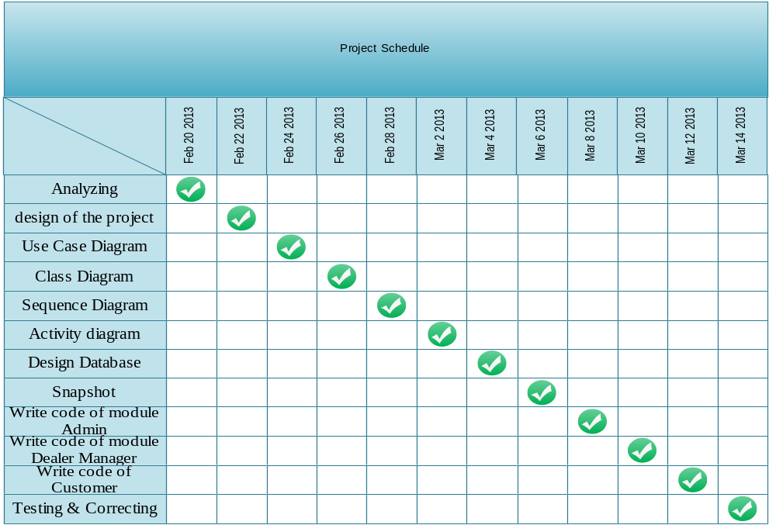

Task Sheet

Project Ref. No.: |  | Date of Preparation of Activity Plan:
No | Task | Actual Start Date | Actual Days | Team Member Names | Status
1 | Analyzing | 20-02-2013 | 2 | All members | Completed
2 | design of the project | 22-02-2013 | 2 | Annv | Completed
3 | Use Case Diagram | 24-02-2013 | 2 | Sonnlb | Completed
4 | Class Diagram | 26-02-2013 | 2 | Sonnlb  DungDT | Completed
5 | Sequence Diagram | 28-02-2013 | 2 | Annv | Completed
6 | Activity diagram | 02-03-2013 | 2 | Sonnlb | Completed
7 | Design Database | 04-03-2013 | 2 | Annv | Completed
8 | Snapshot | 06-03-2013 | 2 | DungDT | Completed
9 | Write code of module Admin | 08-03-2013 | 8 | DungDT | Completed
10 | Write code of module Dealer Manager | 10-03-2013 | 8 | Annv | Completed
11 | Write code of Customer | 12-04-2013 | 8 | DungDT | Completed
12 | Testing & Correcting | 14-03-2013 | 2 | Sonnlb | Completed

Checklists

Check List of Validation

Checklist Option | Validated
Can a new user who gets registered, enter the web site after logging in? | Yes
Do all the links navigate to the correct web page? | Yes
Does the web site’s functionality resolve the client problem and satisfy his need? | Yes
Has the hardware and software been correctly chosen? | yes

Submission Checklist

Sr.No | Particulars | Yes | No | NA | Comments
1 | Are the users able to enter the web site after validation is performed on the UserID and password? | Yes
2 | Are the users able to enter the web site after getting registed? | Yes
3 | Do all the web page contents are devoid of spelling mistakes? | Yes
4 | Is the user able to post entry to the web site | Yes
5 | Do all user and visitor able to view forum | Yes
6 | Admin able manage activity of forum | Yes
7 | Is the web site user- friendly | Yes

Screenshots

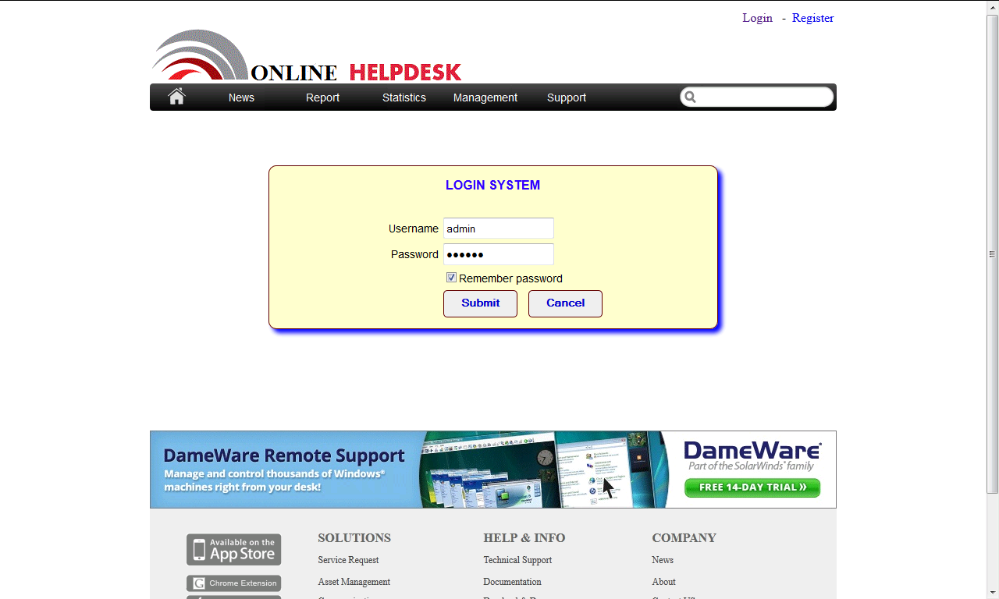
login

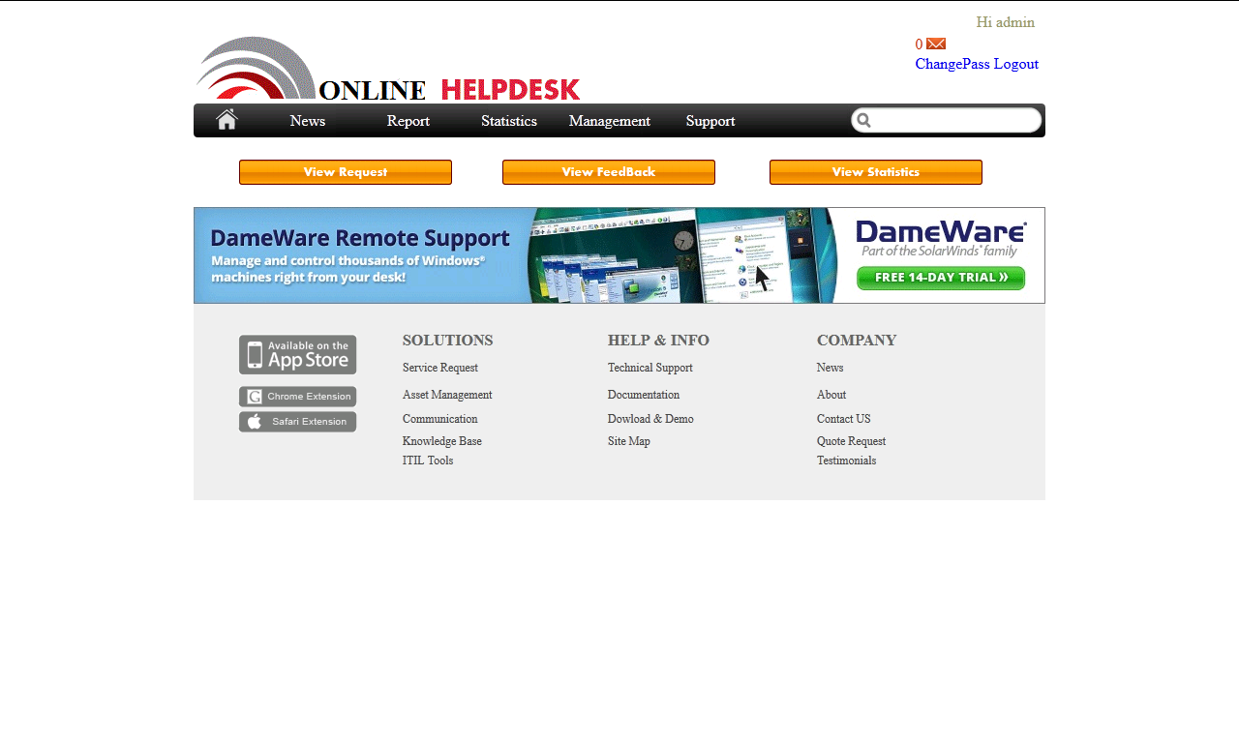
Admin manager

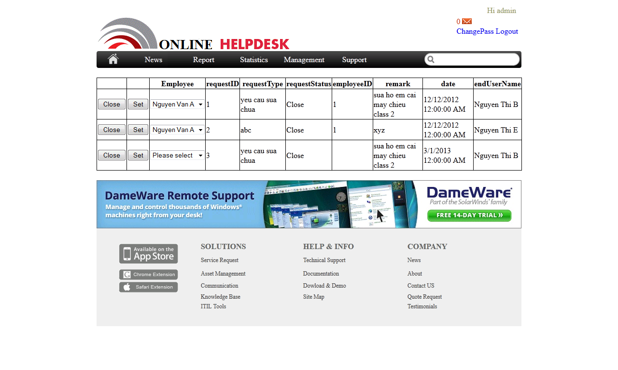
LIST REQUESTS
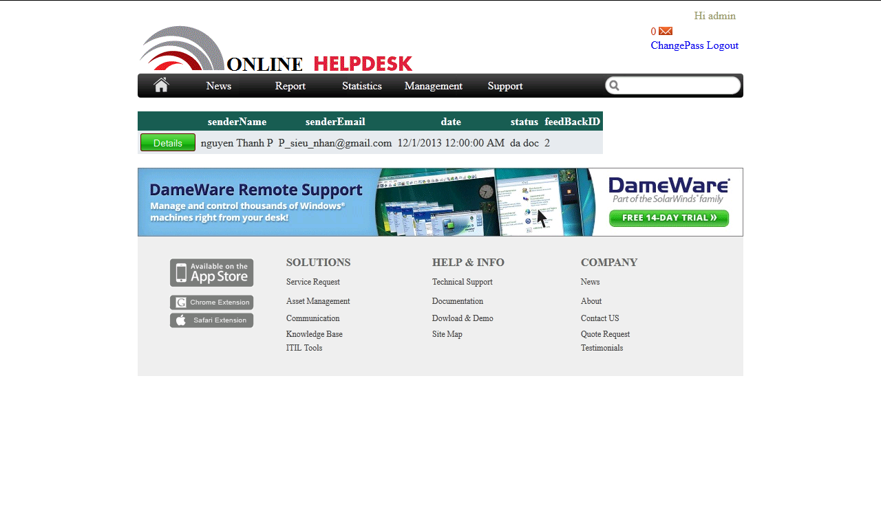
LIST FEEDBACKS
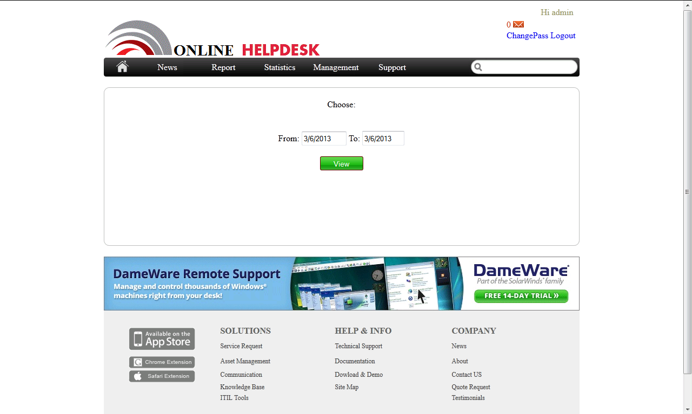
CHOOSE DATE

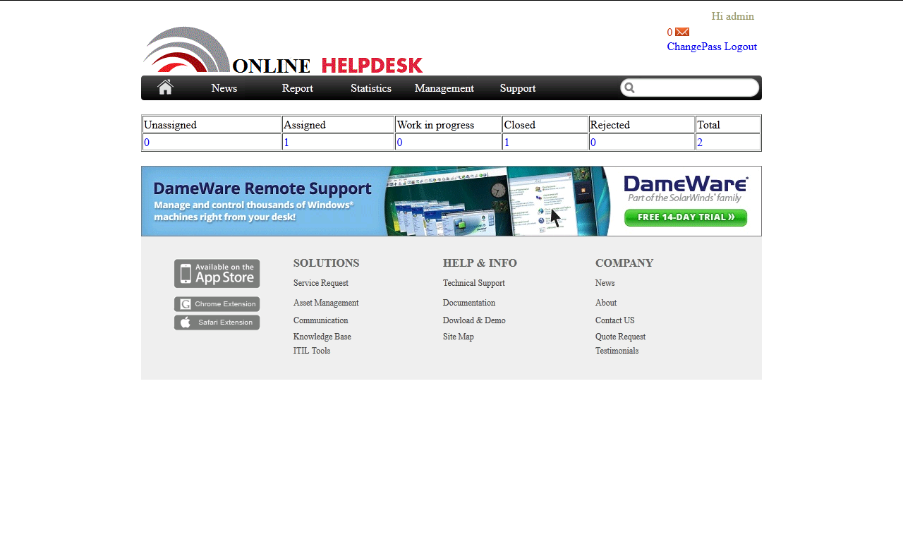
STATICTIS
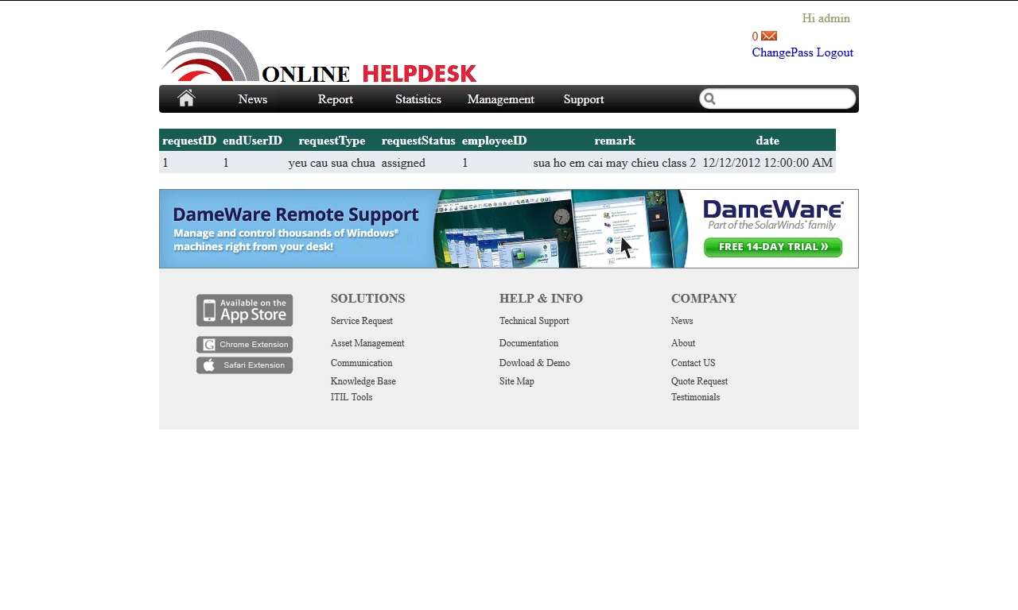
View each status

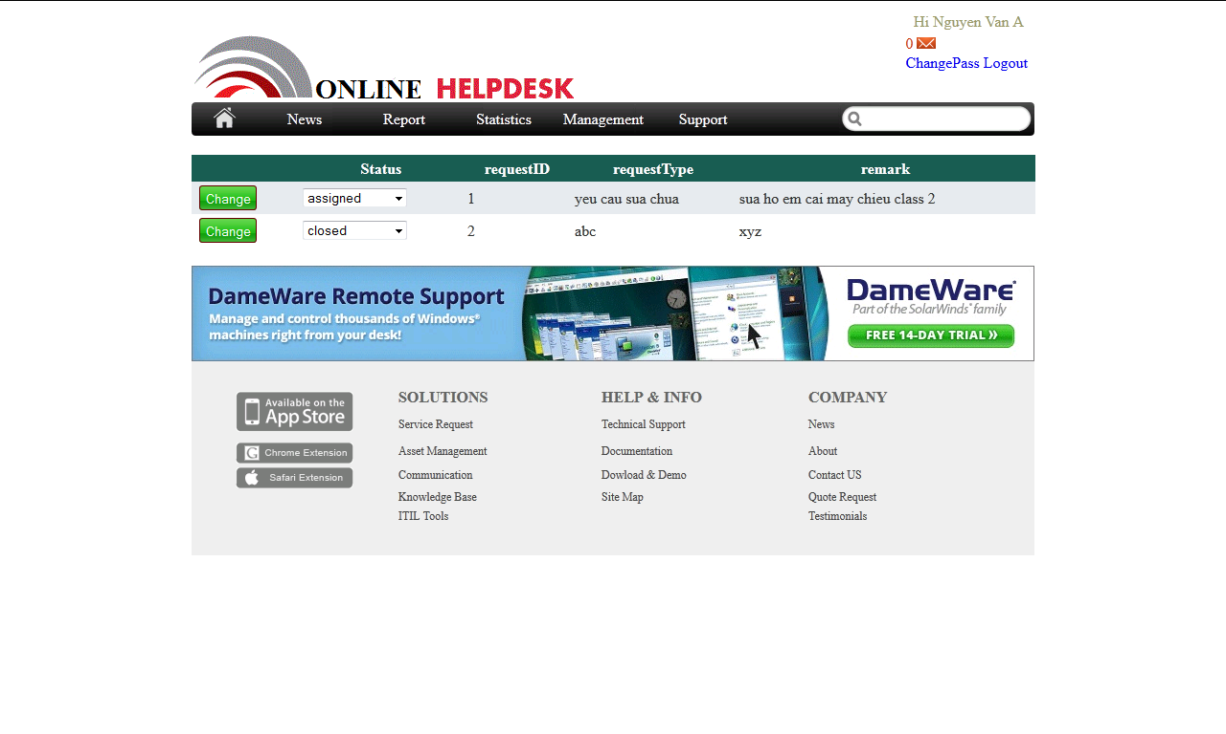
Change status

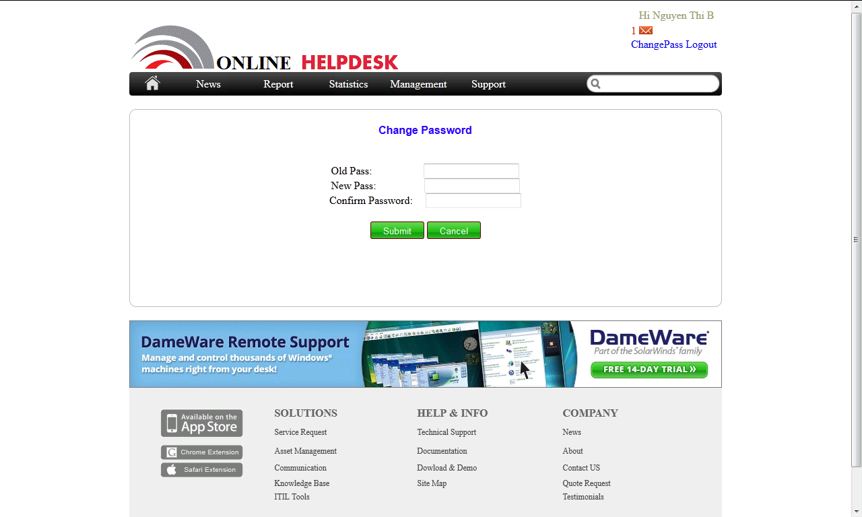
Change password

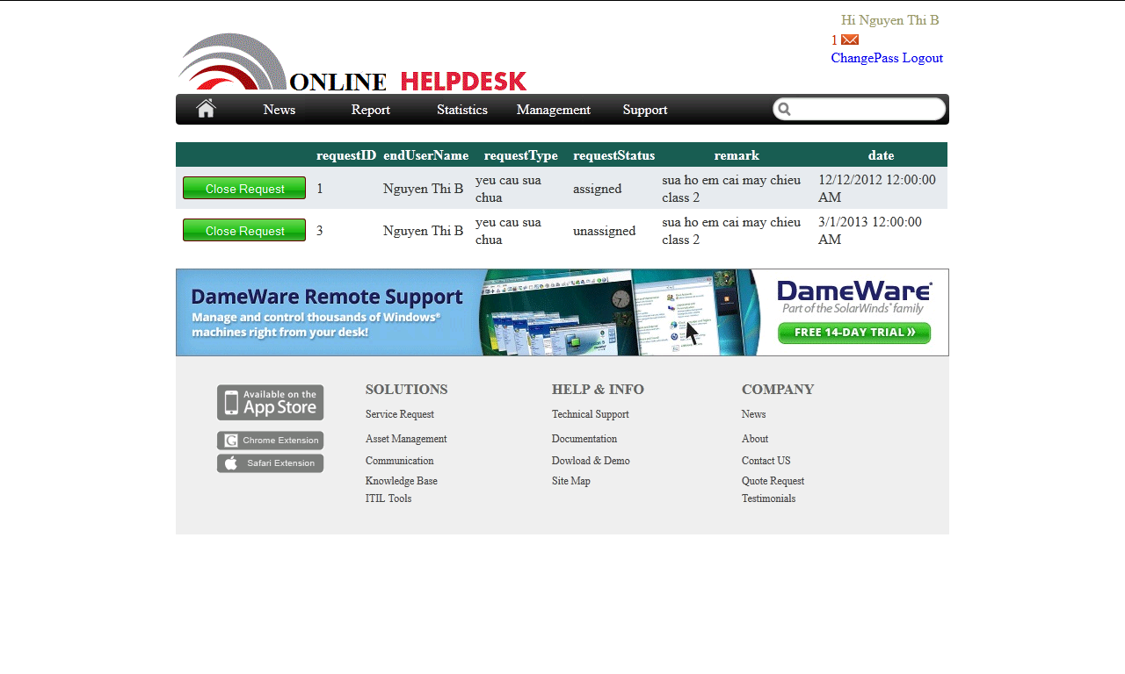
Close request

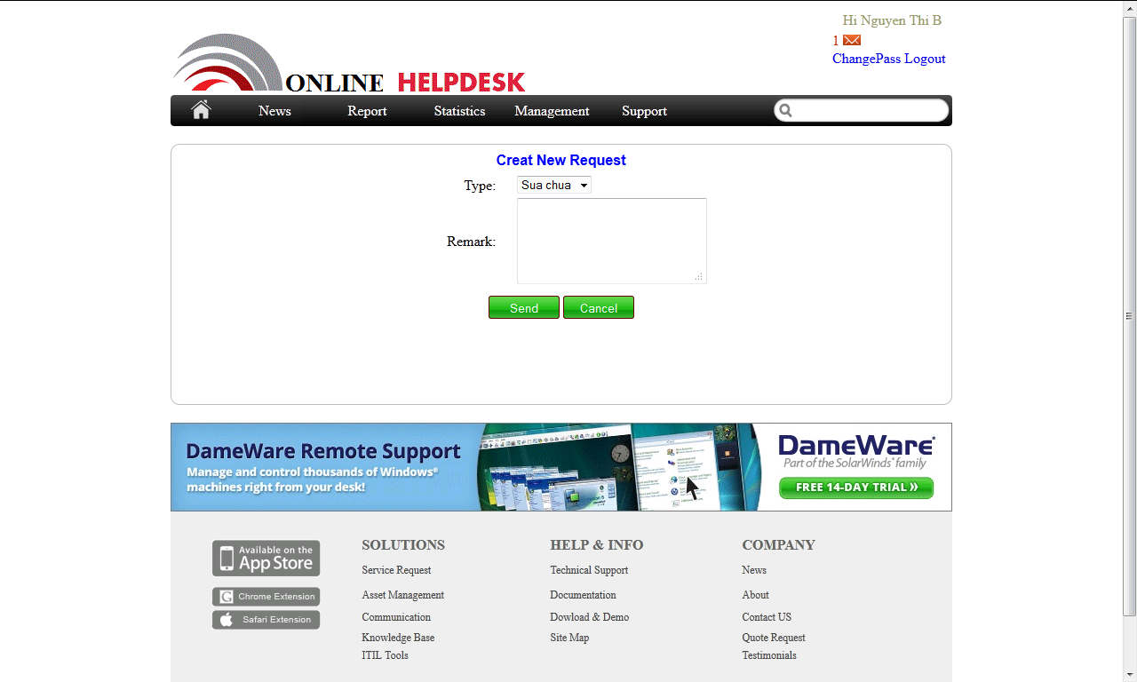
Create New request

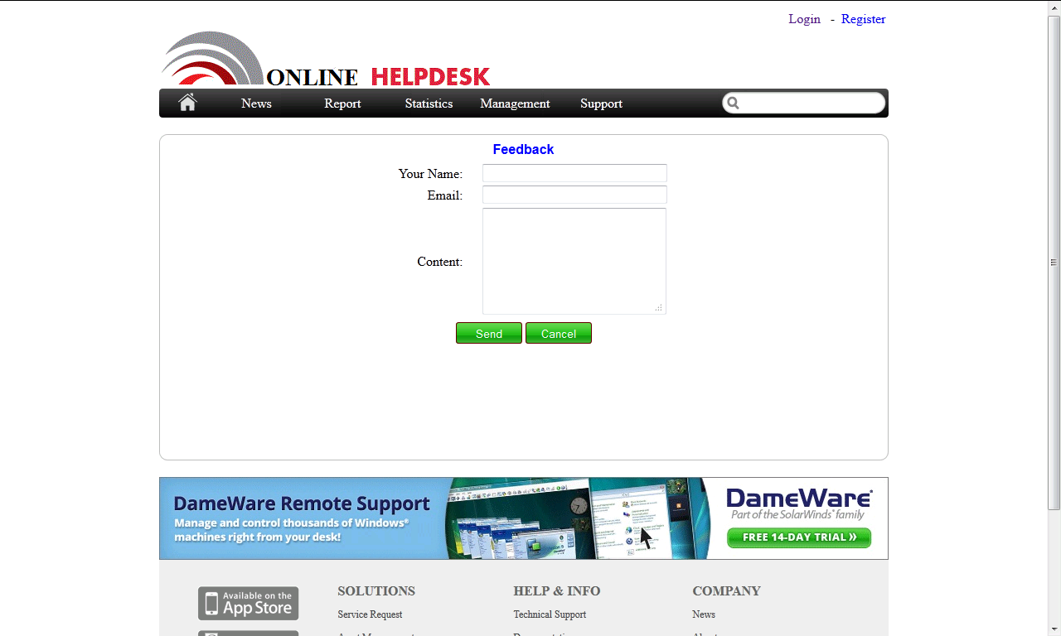
feedback

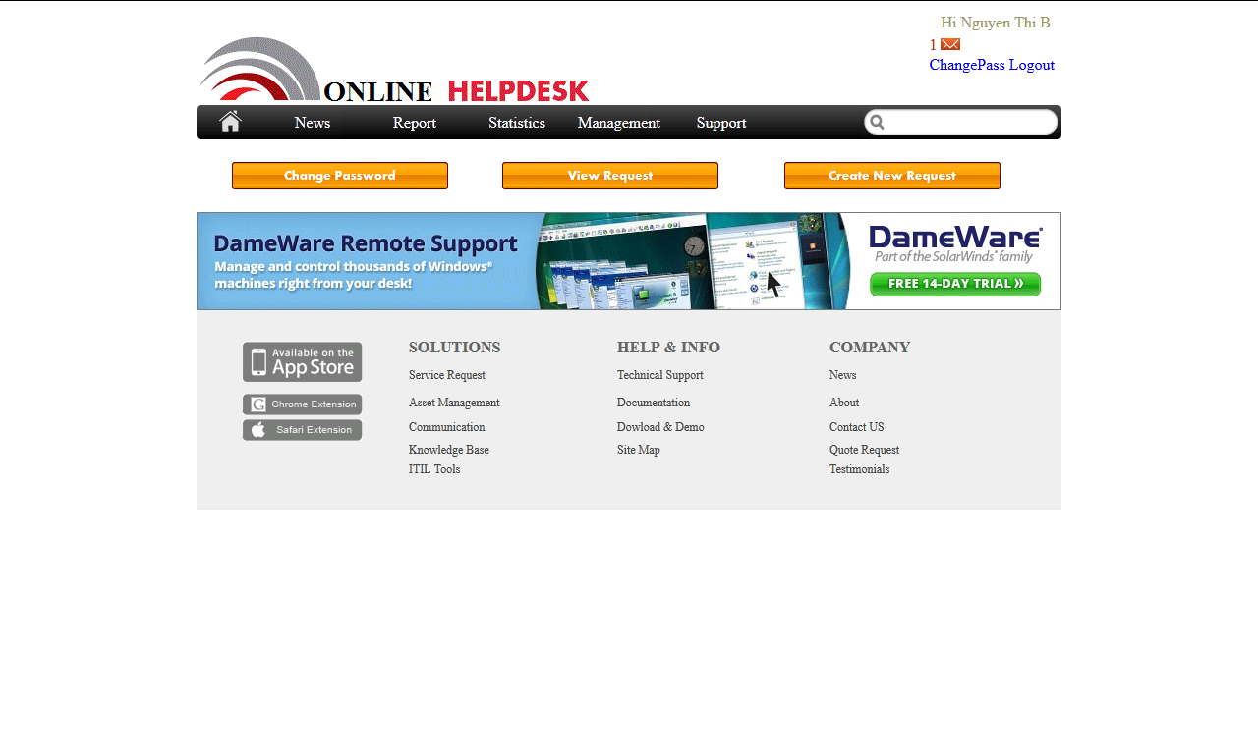
Users manager

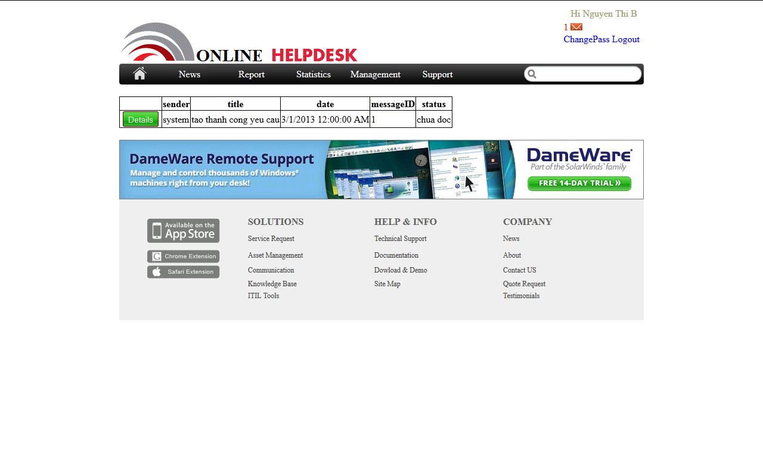
Email list

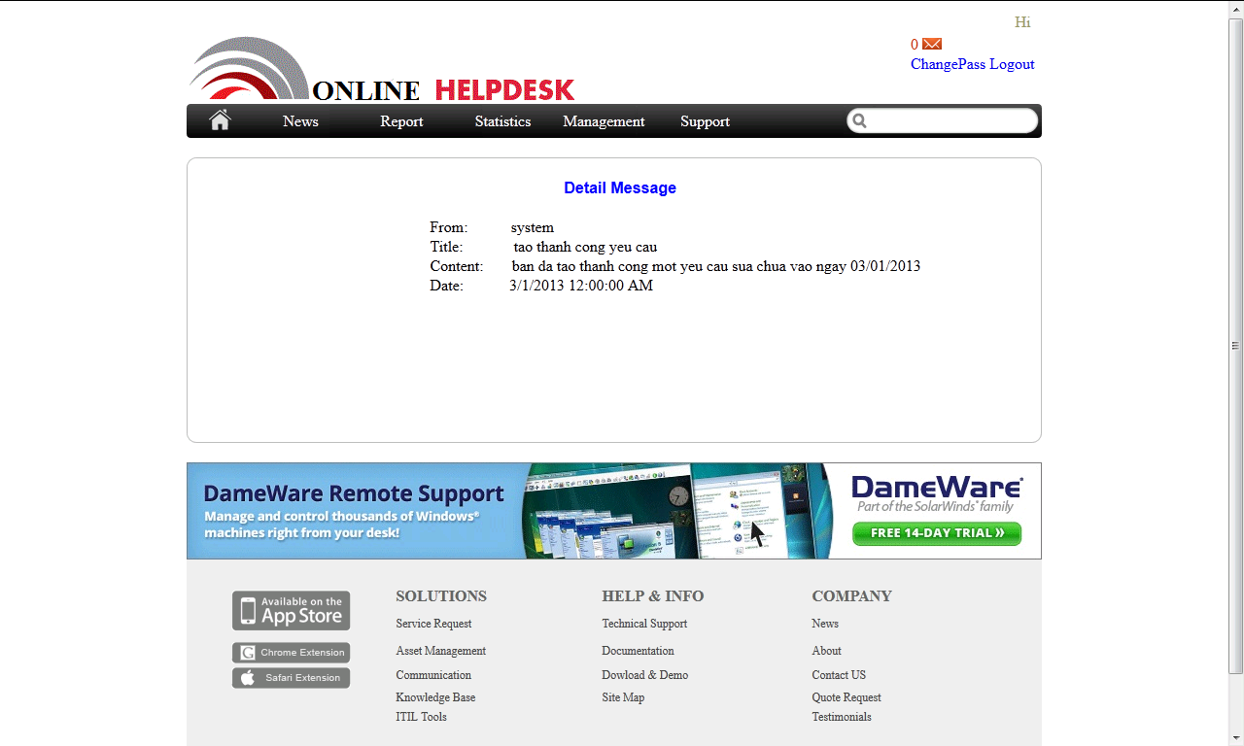
Details email

